Module Leader/Tutor

David Gamez/Padma Daryanani

Social Networking site Proposal

Gabriel Felip Mano Lasig (M00864474)

Contents

Introduction and Proposal: 2

Functionality of Website: 2

Wireframes: 3

“Welcome” Page: 3

“Build” Page: 4

“Items” Page: 6

“Game Updates” Page: 6

Account Pages: 7

Posting Page: 8

MongoDB Database Design: 9

Conclusion: 14

# Introduction and Proposal:

This social networking site revolves around the theme of providing users with guides and in-depth information of various “builds” for the recently released videogame “THE FINALS”. The website also allows users to upload their own guides for the purpose of sharing their knowledge of the game and trying to help newer players to get more comfortable and confident in the game.

“THE FINALS” is a three-person team arena-based shooter with either the goal of gaining the most amount of money (or points to put it in simpler terms) than the other teams of threes before the time runs out or reaching a specific amount of money before the other teams. In this game, players can use 3 different classes, with each containing different equipment and abilities which promotes diverse ways of playing the game, changing your “playstyle” every time you get into a match. There are some builds that are great for the more competitive players, and there are some that can be more experimental yet fun to play on the occasion. This website would be great on sharing those builds and guides for those builds for anyone to read and use.

# Functionality of Website:

This website can be broken down into 4 different “sections” which’ll make up the site:

1. Updates

This section of the website mainly covers any minor or major updates made in the game. Descriptions of updates cannot be sorted differently other than the most recent update post being placed at the very top of the page.

1. Welcome and Basic information

Mainly for newer or returning users, this page covers all the basics of what the game has to offer, giving quick and informative descriptions of each part of the game, ranging from talking about the 3 classes in the game to every game mode available in the game and how they work.

1. Builds

Users can share their builds and set ups that they enjoy using in the game and think it’s worth sharing to other people interested in the game, whether casually or competitively. The builds section can sort posts based on either the date the post has been added, or based on the rating users have on the post.

1. Items

This page is like the 2nd page mentioned and, in the future, may merge. The goal of this page is to provide quick and simple information about every piece of item/equipment that’s available in the game. This means showing the name of an item/equipment, then next to it give a brief description of said item/equipment.

# Wireframes:

## “Welcome” Page:

An example as to what the website may look like the first time loading into the site. Another variation is moving the headers to the left side, allowing it to “collapse” and giving the centre site more space. This is also where the basic information about the game can also be seen, briefly describing what the game is and what to expect to find around the game, like the different game modes to the variety of items to buy. This page can also help in telling the user where to “move around” the site, providing various links to click.

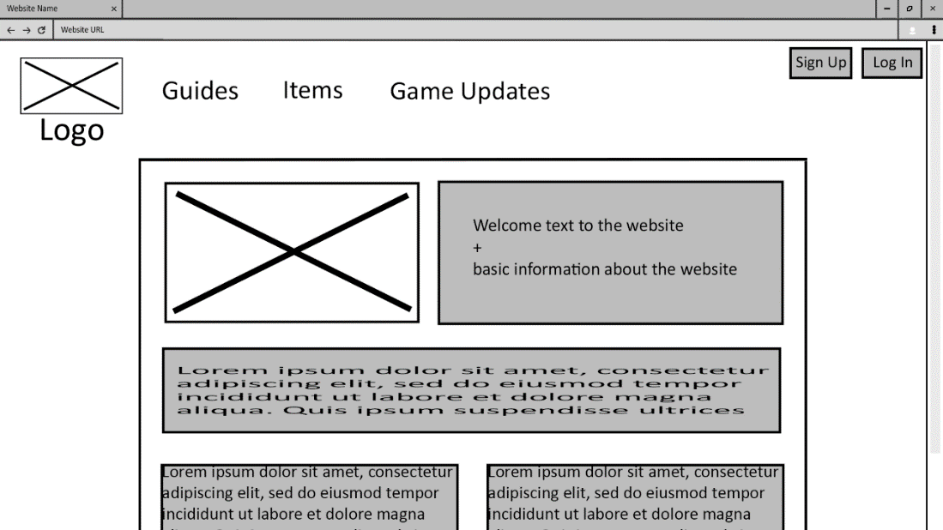

This is what it looks like after scrolling down a little bit. The purpose of the wireframe below is to mainly showcase the footer, and what the main content could look like if the user were to scroll down.

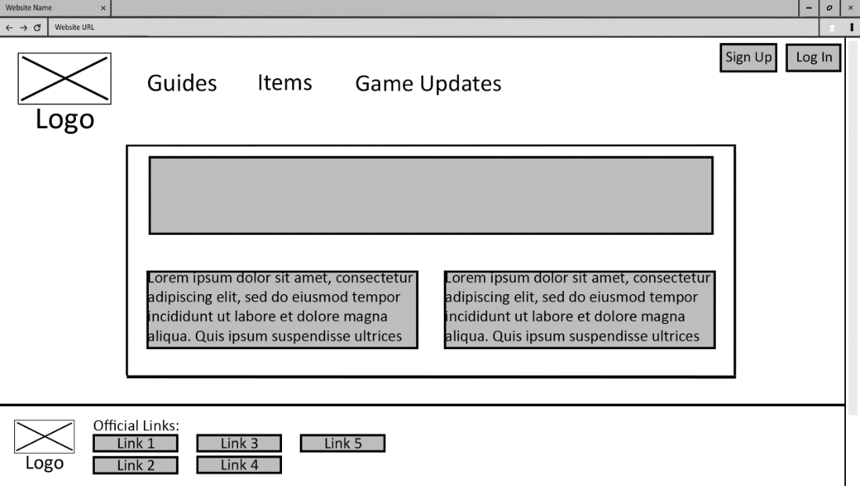

As you can see, the content within the box moves down, but the outer contents such as the header is static, such that it doesn’t move along with the scroll. This can of course change but it is one of many ways the website interacts with various elements. The footer is also minimal but effective, showing links related to the game.

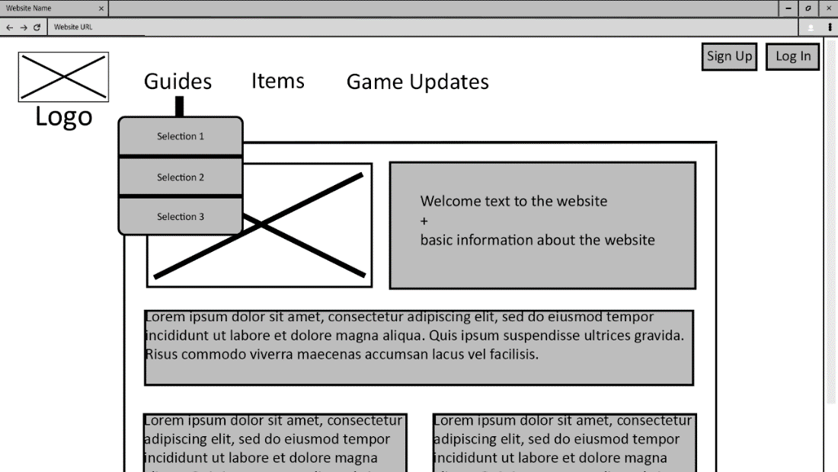

The wireframe above showcases what a “pop-up” would look like when hovering one of the headers. It effectively tells the user the available options in a simple and non-intrusive or non-offensive way. This effect would also work with the Items header, instead that having 4 options: “General”, and each of the three classes.

## “Build” Page:

The following wireframe is an example of what the site updates to when choosing either of the 3 options. Keep in mind that the way it looks would be the same or closely like, for every option available, to make development easier.

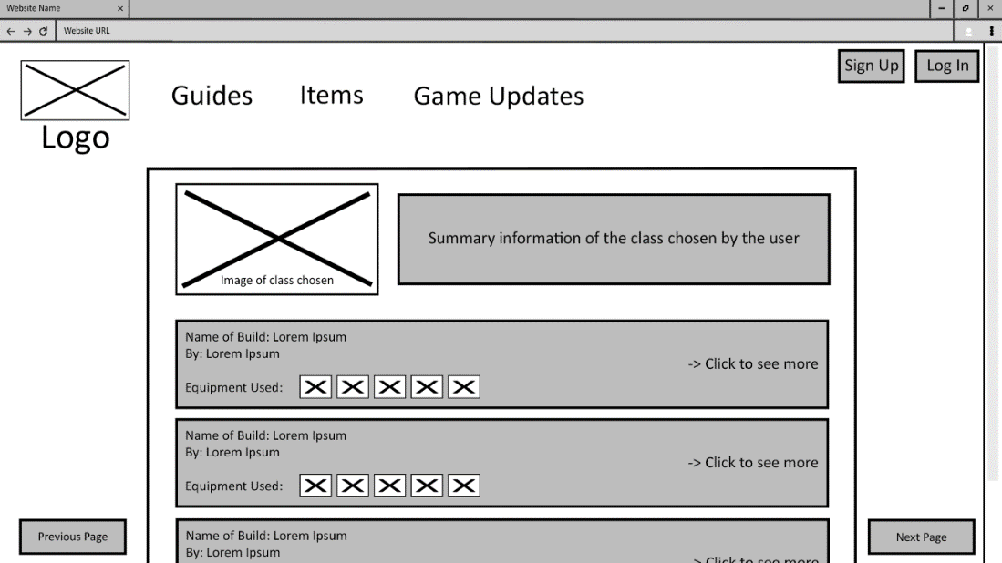

It is formatted like a list, which by default should be sorted by most recent posted. Each item of this list contains enough information to tell the user what the build consists of, but in case they want to know more about the build, it tells the user to click on the item, updating the page to a more detailed explanation of the build from the creator of the post.

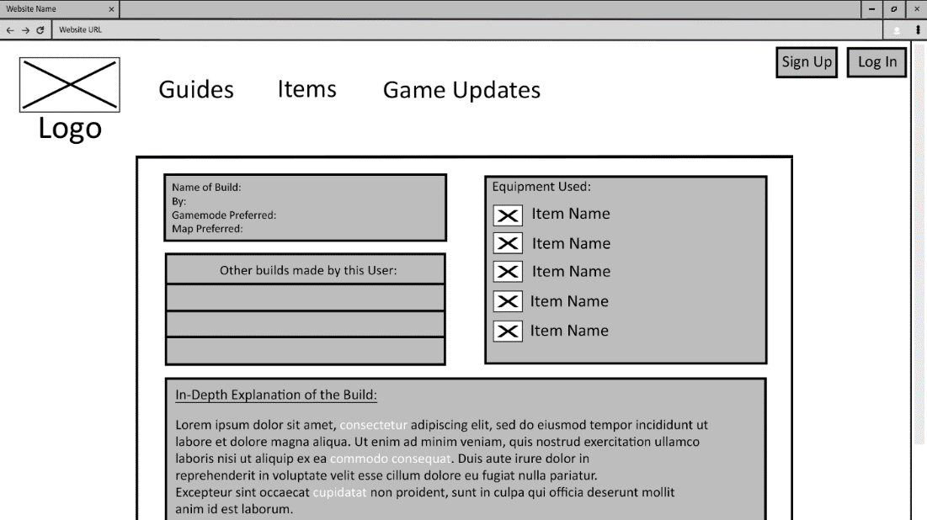

The user will be able to read through the creator of the post’s full explanation and reasoning of the build he decided to share. This could contain how effective this build is depending on what map or game mode you play on; how fun the build is to use in-game and much more. The creator is allowed to show more important key details of the build in various ways; this may include bolding/highlighting certain words or underlining sentences. If the user were to like this post and want to see more from them, there is a small section where it shows other builds made by the creator of the post.

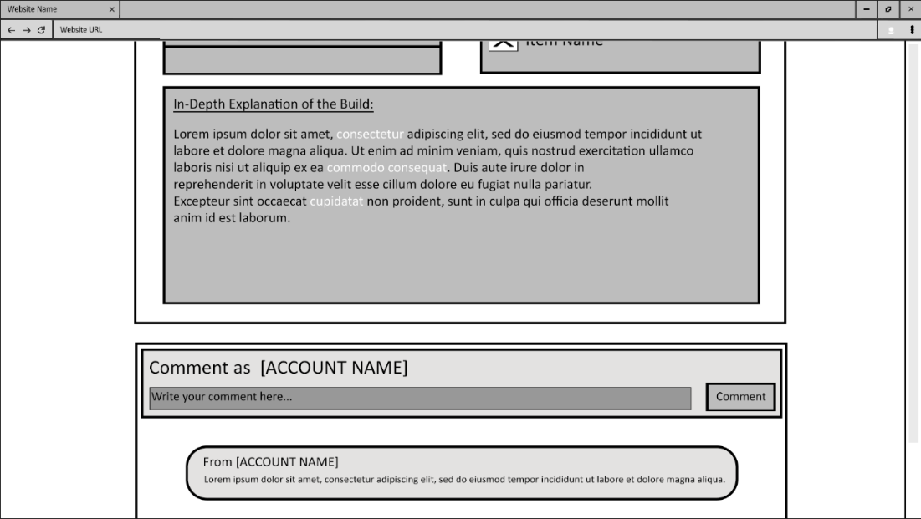

Only when logged in, the user can put in comments under the creator’s posts. This is where users can share their opinions of the builds. It will also tell the user under what name the post will be associated with depending on the account name given during creation.

## “Items” Page:

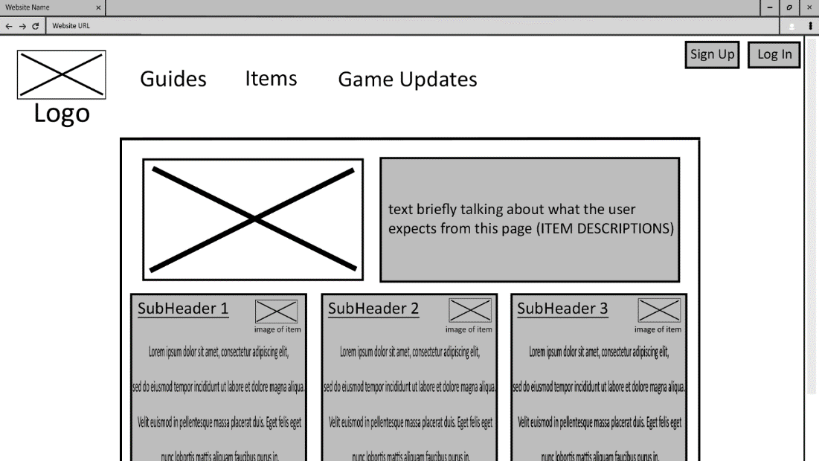

This page, which could merge with the “Welcome” page, splits the “content box” into three columns plus an extra row at the very top, which mainly acts as a sort of header or main title of the page. With these three columns, various items are listed downwards in no order, and are given a brief description of what each piece of item does in the game. An image of said item is complemented, seen next to the name of the item (SubHeader1, followed by an image). The reason to possibly merge with the “Welcome” page is because it can be useful for newer to current players to see information like this right as they come to the site. By the time I’m writing this, there aren’t too many items in the game that would clutter the main page, but a separate page is also useful in case there’s more items to be added in the future.

## “Game Updates” Page:

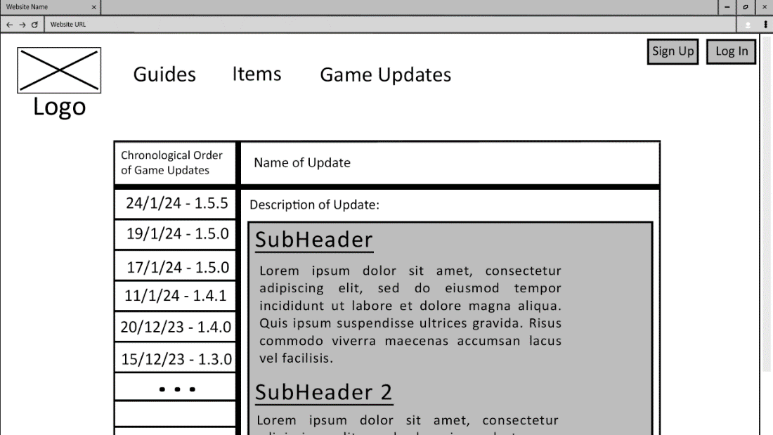

The way this page is laid out is by putting the order of updates in chronological order, and those are put on one side of the “content box”. The main part of the content in those updates change take the majority of the “content box”, and it changes as the user selects between game updates. Specific changes are clearly shown with the underlines showing a new “topic” with text at the bottom of it to further explain the changes made to it. It should be able to scroll up and down if there’s a lot of text to read through.

## Account Pages:

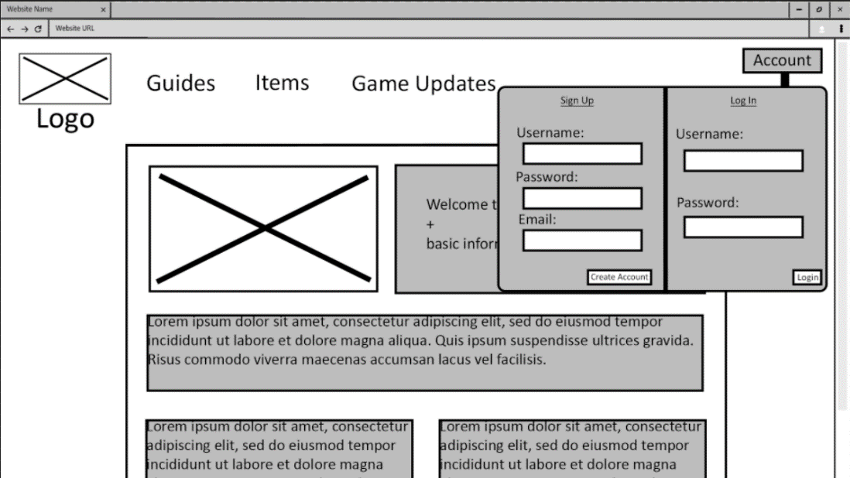

This is an instance of what the site will look like if you were to press the “Account” button on the top-right. Assuming you’re not logged in, a menu drops down and asks the user to either sign up or log in. Clicking away or the button again will remove the menu.

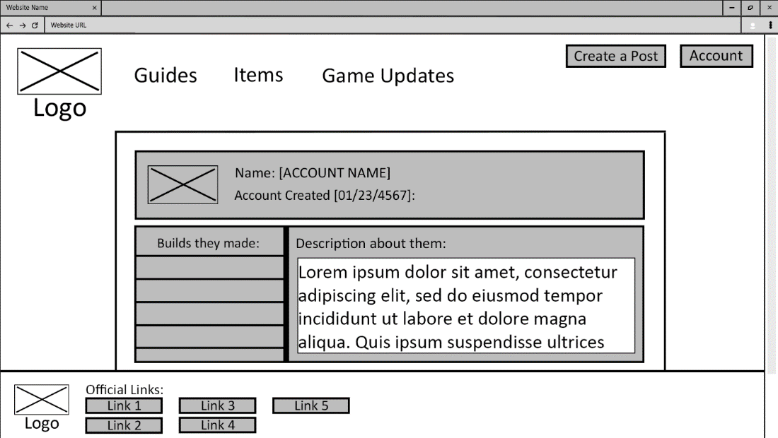

This is an example of what the page will look like when viewing other people’s accounts. A very simple layout displaying the name of the account, the date it was created, the other posts they’ve made on the website, and a small text box briefly describing the account. This will pop up when clicking the name in posts, or when you click the “Account” button after logging in/creating an account. Also, once logged in a new button pops up that allows the user to create a new post. This will not be available if they’re not logged in, like how you can’t comment when not logged in.

## Posting Page:

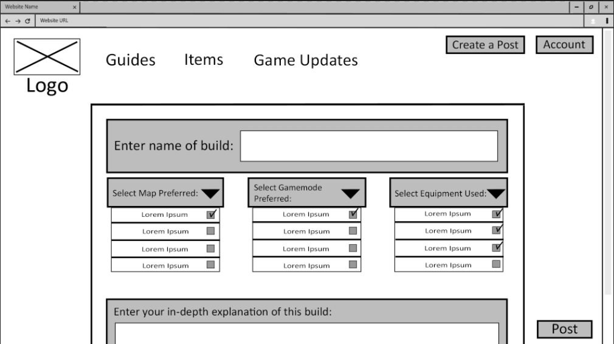

# MongoDB Database Design:

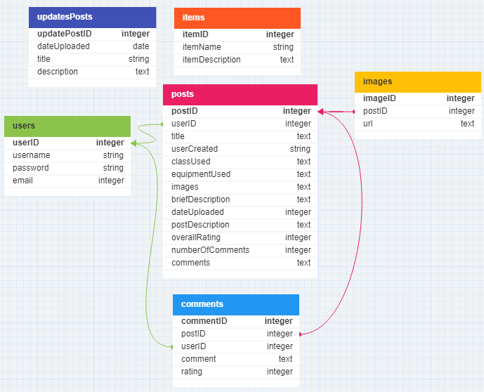

This is what the database may look like for this project. For every post, it has one or many comments. Therefore, in the comments collection a foreign key is made using “postID”, showing the relationship between the two collections. Each post is linked to one specific user, meaning one user can have more than one post, so a foreign key is made under the posts collection using the “userID”, also showing the relationship between the two. Also in a post, it also contains images. Moreover, images in posts are unique to that post, even if another post has an image similar or close to another image from another post. Therefore, the images collection also has a relationship with the posts collection.

As for the other two collections, updatesPosts and items, while it is part of the whole database, it inherently does not have any sort of relationship with other collections unlike I previously talked. Although, one possible change to this is to link the collection “items” with both “updatesPosts” and “posts” since in both pages it’ll most likely contain at least one piece of data from “items”. This also makes data retrieval easier since it means just communicating with each other rather than having to input data manually.

Here are screenshots of the documents seen in MongoDB Compass:

Users:

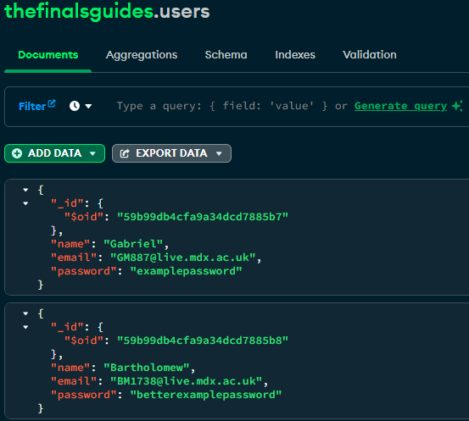

Posts:

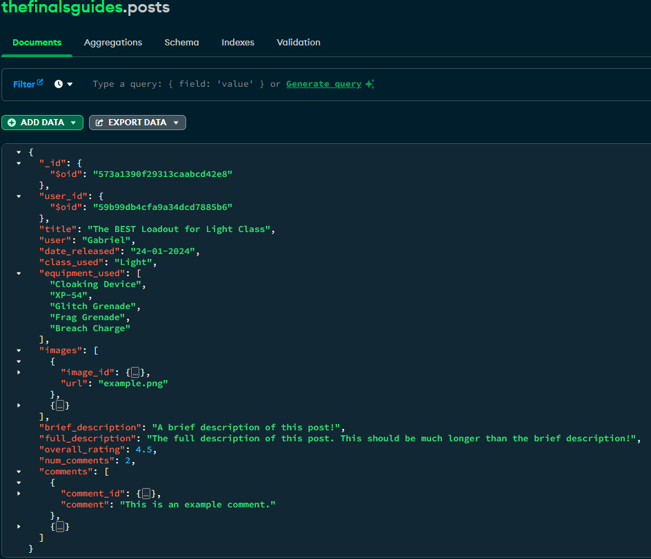

Image:

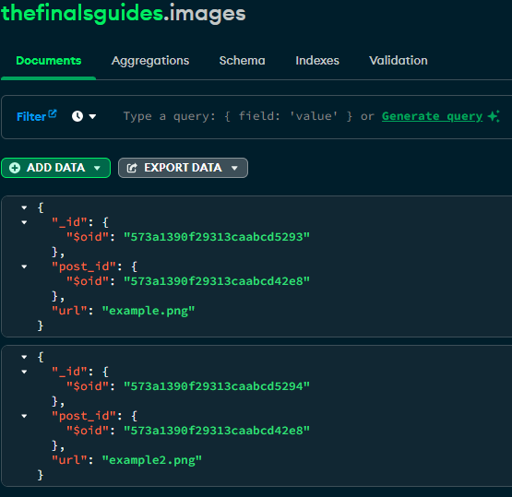

Comments:

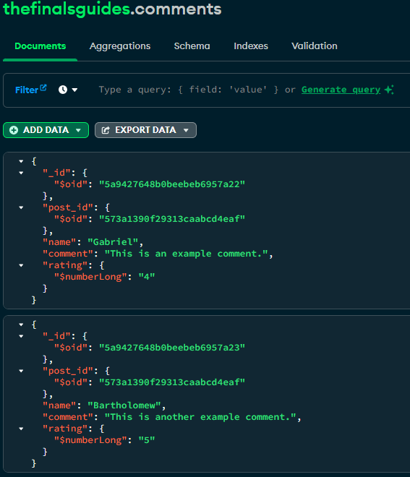

Updates and Items:

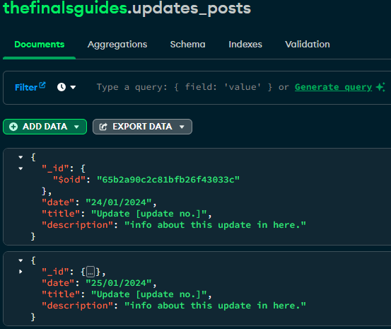

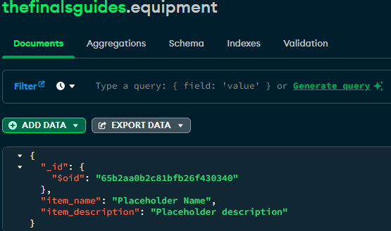

# Conclusion:

This website will be built with only using a single HTML page and relying on a dedicated server like MongoDB to handle transferring and storing data from the browser. Using JavaScript along with Node.JS to allow the transfer of data between the browser and the server in real time, and using third-party libraries such as Bootstrap or jQuery will make this website feel fluid and professional-like. The advantage of having a web server is that it eliminates security concerns regarding sensitive user data and how it can be accessed. Same thing with the website contents, while it can be edited locally, any local changes wouldn’t update to anybody else.